Illustration 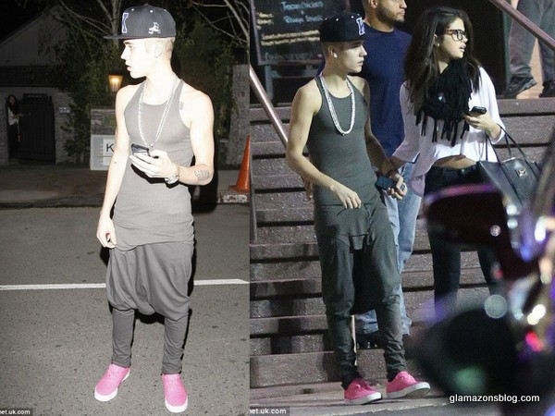1: Penis

Adsfadfsdfasdfasdfasdfasdfasdfasdf;lkj;lkj;lkj;lkj;lkj;lkjasdfasdfasdfsadfasdf